SIMATS ENGINEERING (SAVEETHA SCHOOL OF ENGINEERING)
Course Code & Title: | ECA5604 -5G/6G COMMUNICATION | Course Faculty: | Dr.K.Sathish
Student Name: | Velamuri Bhanodhay | Reg. No.: | 192412330
Dept / Batch: | BE.ECE / 2024 | Date: | 03/8/2026
Lab Observation

Experiment 7 : Analog Beam forming Analysis Using MATLAB

Objective 1: To analyze the beam forming gain achieved by varying the number of antenna elements in
an analog beamforming system using MATLAB.

Matlab Code:

clc;
clear;
close all;
antennas = [2 4 8 16 32]; % Number of Antenna Elements
gain = 10*log10(antennas); % Beamforming Gain (dB)
figure
bar(antennas, gain)
grid on
xlabel('Number of Antenna Elements')
ylabel('Beamforming Gain (dB)')
title('Beamforming Gain for Different Antenna Array Sizes')

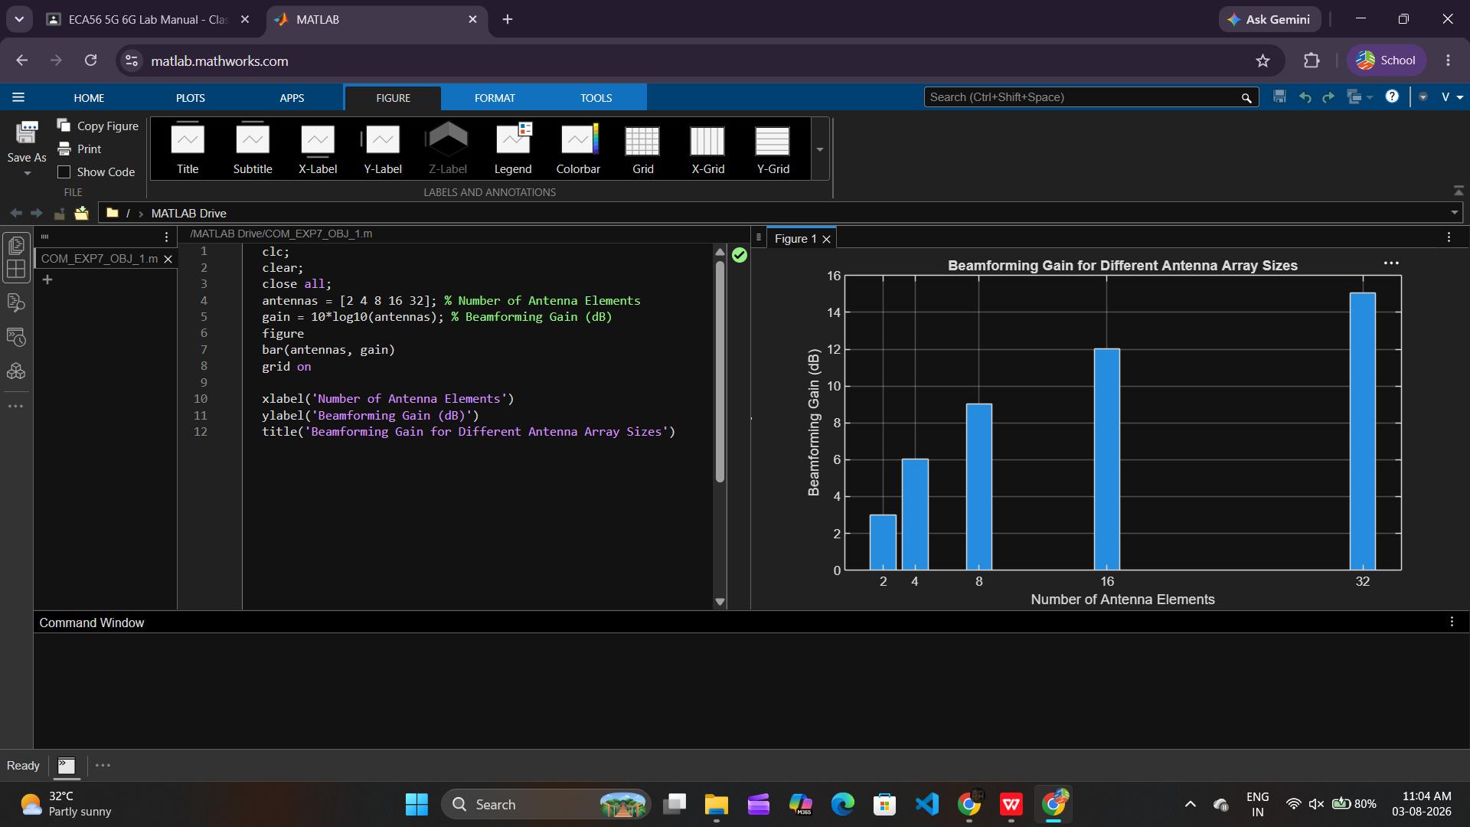

Objective 2: To compare the beam width of an antenna array for different beamforming configurations
using MATLAB.

Matlab Code:

clc;
clear;
close all;
antennas = [2 4 8 16 32]; % Number of Antenna Elements
beamwidth = [90 45 22.5 11.25 5.625]; % Beam Width (degrees)
figure
plot(antennas, beamwidth,'o-','LineWidth',2)
grid on
xlabel('Number of Antenna Elements')
ylabel('Beam Width (Degrees)')
title('Beam Width for Different Antenna Array Sizes')

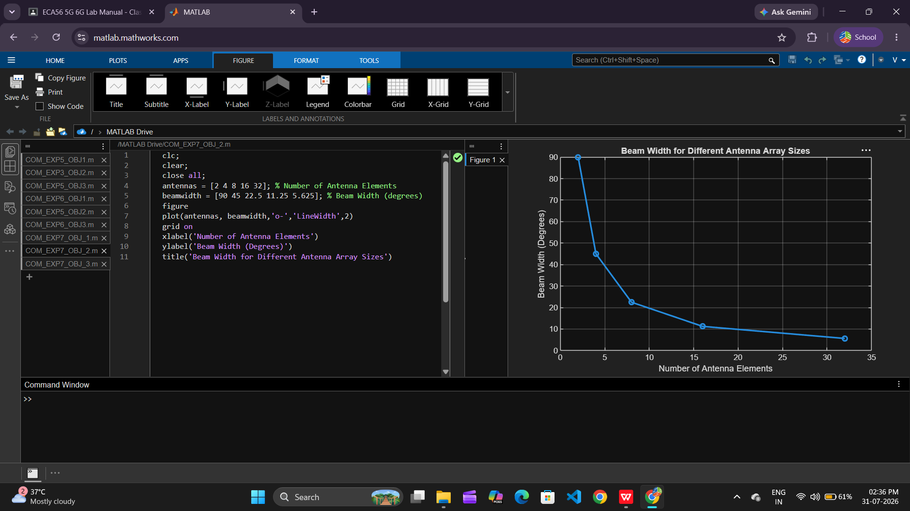

Objective 3: To analyze the main lobe direction by steering the antenna array beam to different angles
using MATLAB.

Matlab Code:

clc;
clear;
close all;
theta = [-60 -30 0 30 60]; % Main Lobe Direction (degrees)
gain = [1 1 1 1 1]; % Constant normalized gain
figure
polarplot(deg2rad(theta), gain, 'o', 'LineWidth', 2)
title('Main Lobe Direction in Analog Beamforming')

